**Task 13-Gemini**

**CSS Variables (Custom Properties)**

**CSS Variables** (also known as **custom properties**) are a powerful feature introduced in CSS3 that allows you to define and reuse values throughout your stylesheet. They provide a flexible and efficient way to maintain consistency and manage styles, especially in complex projects.

**How They Work**

1. **Declaration:** Variables are declared using the -- prefix followed by the variable name. For example:

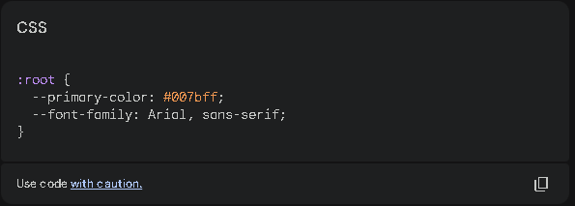

1. **Usage:** To use a variable, reference it using the var() function. For example:

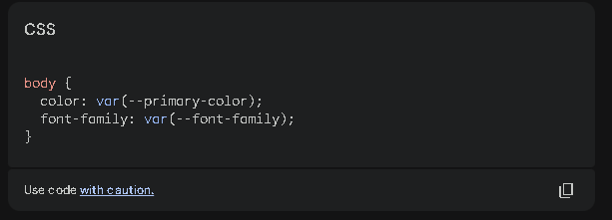

Example: Maintaining Consistency

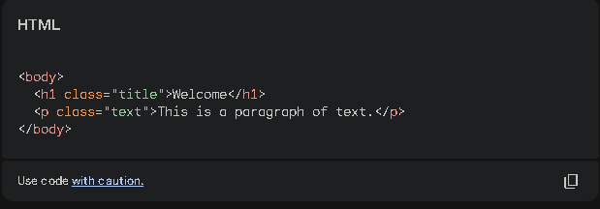

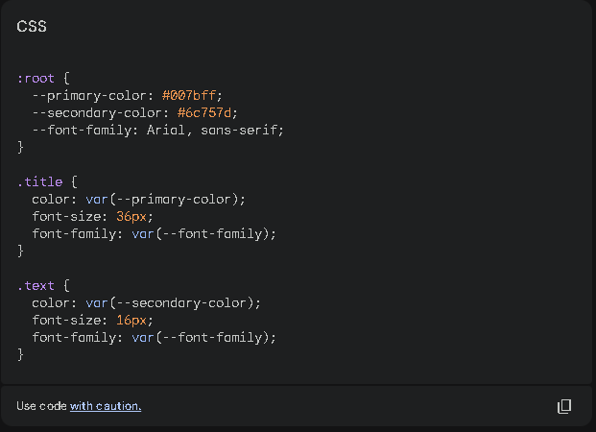

In this example, we define two color variables (--primary-color and --secondary-color) and a font family variable (--font-family). These variables are then used to style the title and text elements.

**Changing Variable Values**

To change the value of a variable, simply modify its declaration in the :root selector. For example, to change the primary color to red:

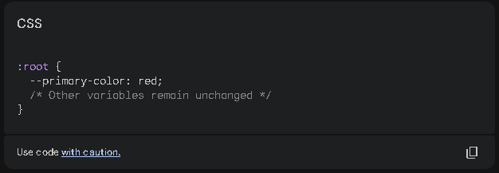

This change will immediately affect all elements that reference the --primary-color variable, such as the title element in the example.

**Benefits of Using CSS Variables**

* **Consistency:** Ensures consistent styling throughout your project.
* **Maintainability:** Makes it easier to update styles in multiple places.
* **Flexibility:** Allows you to easily change the overall appearance of your website.
* **Themeability:** Can be used to create different themes or skins for your website.

By using CSS variables, you can create more flexible, maintainable, and visually appealing stylesheets.